Nonprofit Know-How 2026
Each year, the Nonprofit Network schedules several fast, free and focused trainings in a learning series called Nonprofit Know-How. These workshops, presentations and training events cover a variety of topics of interest to nonprofit employees. Each event format, length and topic is unique. Nonprofit Know-How attendance is free, but registration is requested.


Nonprofit Know-How: how the community foundation can SUPPORT your nonprofit
Thursday, January 29, 2026, 9:30 to 11:30 a.m.
Cedar Rapids Public Library, 450 5th Ave SE, Cedar Rapids, Beems Auditorium A/B

Meet the staff and learn how the Community Foundation can support your nonprofit in 2026. Community Foundation staff will share 2026 funding opportunities, new and existing marketing resources, nonprofit funds and endowment building, and new learning opportunities. Following the formal presentations, staff will be available for individual conversations and questions. Information shared will be available at gcrcf.org following the event.


Nonprofit Know-How: BUDGETING AND FINANCE ESSENTIALS
Wednesday, March 11, 2026, 9:30 to 11:30 a.m.
Cedar Rapids Public Library, 450 5th Ave SE, Cedar Rapids, Whipple Auditorium

Presenters Joe Heitz, Vice President of Community Impact at the Greater Cedar Rapids Community Foundation, and former executive director, and David Little, CPA, Principal at CLA will share practical budgeting tools, help participants gain a clear understanding of nonprofit financial statements, offer tips to avoid common pitfalls, and instill confidence to communicate financial needs to boards, funders, and staff.

Training and communication needs are changing rapidly in 2026. The August and December Nonprofit Know-How topics are to be determined, but please save the dates.


Nonprofit Know-How: TBD
Wednesday, August 12, 2026, 9:30 to 11:30 a.m.
Cedar Rapids Public Library, 450 5th Ave SE, Cedar Rapids, Beems Auditorium A/B

More information soon about the presenter and format of this learning opportunity.


Nonprofit Know-How: TBD
Wednesday, December 9, 2026, 9:30 to 11:30 a.m.
Cedar Rapids Public Library, 450 5th Ave SE, Cedar Rapids, Beems Auditorium A/B

More information soon about the presenter and format of this learning opportunity.

Thank you to the Cedar Rapids Public Library for their partnership to host the 2026 Nonprofit Know-How events.

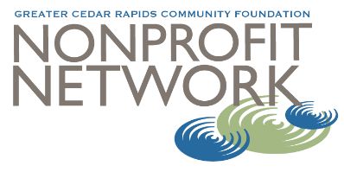
For more information contact:
Carrie Walker, Vice President of Learning
Greater Cedar Rapids Community Foundation
carrie.walker@gcrcf.org
319.774.2375

