MARKETING Peer Group

2025 Schedule

DATE | PEER GROUPS | NONPROFIT KNOW-HOW | TOPIC
 | 12 – 1 p.m.  Greater Cedar Rapids Community Foundation, Foundation Hall  4th Tuesday of select months | 9:30 – 11:30 a.m.  Cedar Rapids Public Library, Beems Auditorium A/B
Tues, Jan 30 |  |  | Grants in 2025
Tues, Feb 25 |  |  | Social Media Strategy: What’s Good, Bad, & Effective
Wed, Mar 12 |  |  | UnCharitable Movie for Nonprofits and Board Members
Tues, Apr 22 |  |  | Approaches to Annual Reports
Tues, May 27 |  |  | Creating Video Content
Tues, Jun 24 |  |  | Working with the Media to Get Your Message Out
July | No Activities
Wed, Aug 6 |  |  | TBD
Thurs, August 14 | Nonprofit Appreciation Day  A new event to celebrate our nonprofit community! More information coming soon!
Tues, Sept 16* |  |  | Legacy Giving
Tues, Oct 28 |  |  | Brand Awareness and Design
Tues, Nov 25 |  |  | Data That Matters
Wed, Dec 10 |  |  | TBD
*Due to a scheduling conflict, Marketing and Development Peer Groups will meet together in September.
Watch for additional learning event announcements in the monthly Nonprofit Network email newsletter.

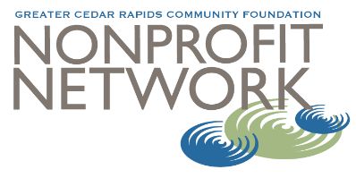
For more information contact:
Carrie Walker, Vice President of Learning
Greater Cedar Rapids Community Foundation
carrie.walker@gcrcf.org
Cell: 319.360.3950

