PLEDGE CARD SUGGESTED WORDING

Credit Card
Gifts can be made by credit card at www.gcrcf.org by selecting the following:
Donate > Search Funds > search fund name here > Details > Donate Now
Single and recurring giving options are available. Visa and MasterCard are accepted.

My pledge will be paid in equal installments:

Beginning (month/year) /
& Ending (month/year) /
Frequency: Annually Semi-Annual
Quarterly Monthly

Your generosity to the Fund Name Here is greatly appreciated.

Name
Phone
Company/Organization
Address
City
Email

State
Zip

My/our total financial commitment to the endowment fund: $
One time gift My company provides matching gifts
Pledge with initial payment
Mail check and pledge card to the Community Foundation
Pledge without initial payment
Mail pledge card directly to: (Add nonprofit name and address here)

Signature

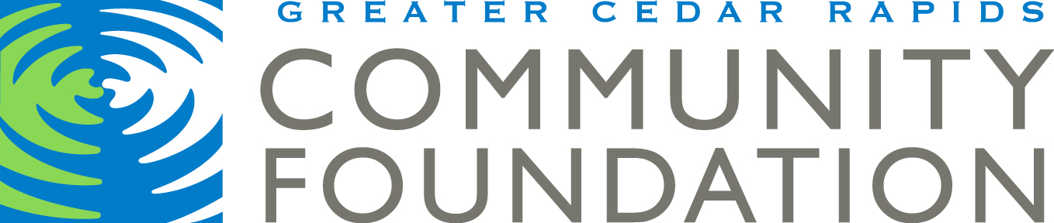
Please return this form to:
Greater Cedar Rapids Community Foundation
324 3rd St SE, Cedar Rapids, IA 52401

The above wording is suggested for pledge card design and the document is available to you in MS Word. Please submit final copy of any drafted pledge cards or requested use of the Community Foundation logo to Laura Booth, Donor Relations Officer, for review prior to printing.

Reminders:
- The Community Foundation does not track pledges.
- Pledge cards are returned to your nonprofit after our processing is complete for your tracking purposes.
- A pledge submitted without payment should be sent directly to your nonprofit.
- Donors must make credit card gifts directly through our web site.
- The Community Foundation accepts MasterCard and Visa.
- Reoccurring pledge payments can be established for corporate donors.
- All contributions are posted to Donor View for your review.

If you have any questions, please call or email Laura Booth at 774-2367 or laura.booth@gcrcf.org.

